**ASSIGNMENT – 1**

**DOMAIN :** IOT – Internet of Things.

**REG. NO :** 211419106073

**Question:**

To build a circuit using Tinkercad software, which consists of 2 sensors, 2 led and a buzzer for alarm at the higher values.

**Circuit:**

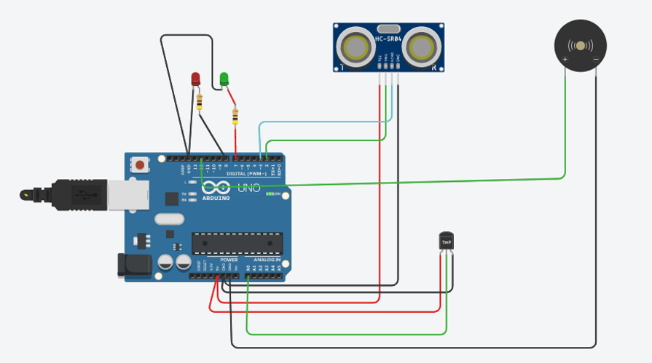

**Code:**

int t=2;

int e=3;

void setup()

{

Serial.begin(9600);

pinMode(t,OUTPUT);

pinMode(e,INPUT);

pinMode(12,OUTPUT);

}

void loop()

{

//ultrasonic sensor

digitalWrite(t,LOW);

digitalWrite(t,HIGH);

delayMicroseconds(10);

digitalWrite(t,LOW);

float dur=pulseIn(e,HIGH);

float dis=(dur*0.0343)/2;

Serial.print("Distance is: ");

Serial.println(dis);

//LED

if(dis>=100)

{

digitalWrite(7,HIGH);

}

if(dis<100)

{

digitalWrite(7,LOW);

}

//Buzzer For ultrasonic Sensor

if(dis>=100)

{

for(int i=0; i<=5; i=i+10)

{

tone(12,i);

delay(1000);

noTone(12);

delay(1000);

}

}

//Temperate Sensor----------------------

double a= analogRead(A0);

double t=(((a/1024)*5)-0.5)*100;

Serial.print("Temp Value: ");

Serial.println(t);

delay(1000);

//Buzzer for Temperature Sensor

if(t>=80)

{

for(int i=0; i<=5; i=i+10)

{

tone(12,i);

delay(1000);

noTone(12);

delay(1000);

}

}

//LED

if(t>=50)

{

digitalWrite(8,HIGH);

}

if(t<50)

{

digitalWrite(8,LOW);

}

}

**Description:**

**Ultrasonic Sensor**

The led and buzzer is pushed to “HIGH” if the distance is greater than or equal to 100 else the buzzer and led are in “LOW” .

**Temprature Sensor:**

The led is pushed to “HIGH” if the temperature value is greater than or equal to 50 else the buzzer and led are in “LOW”.

The buzzer is pushed to “HIGH” if the temperature value is greater than or equal to 80 ,else the buzzer and led are in “LOW”.

**Output :**

